**Studio Room   
$219 per night**

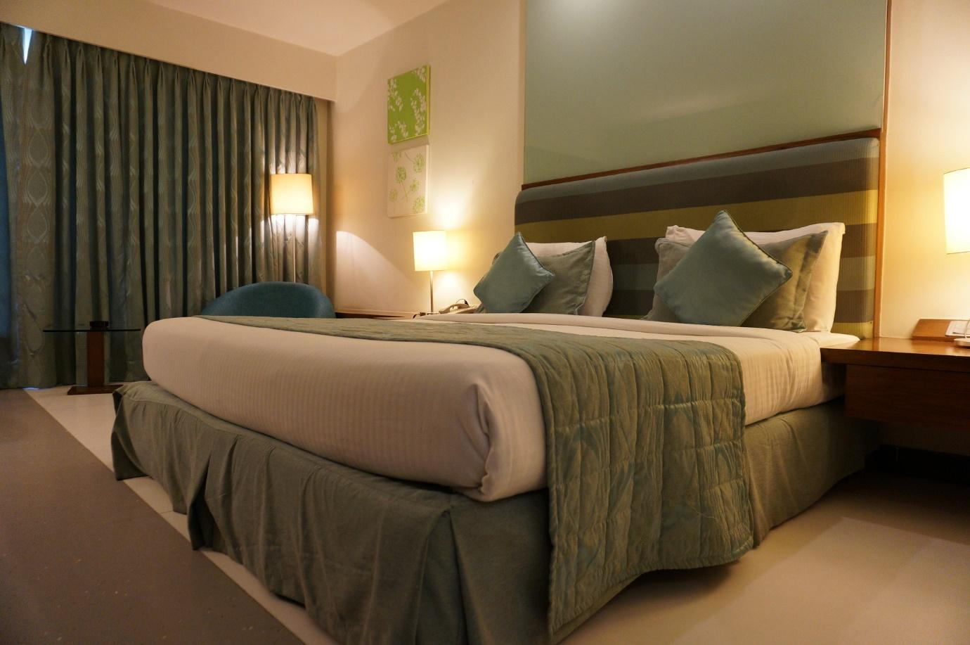

Ideal combination of style and functionality, offering modern ensuite with walk-in shower, washer/dryer. Fridge & microwave

 31m², Super King bed, 1-2 guests.

Air-conditioning, 55" flat screen TV with SKY channels

FREE unlimited WiFi.

**Executive Studio  
$249 per night**

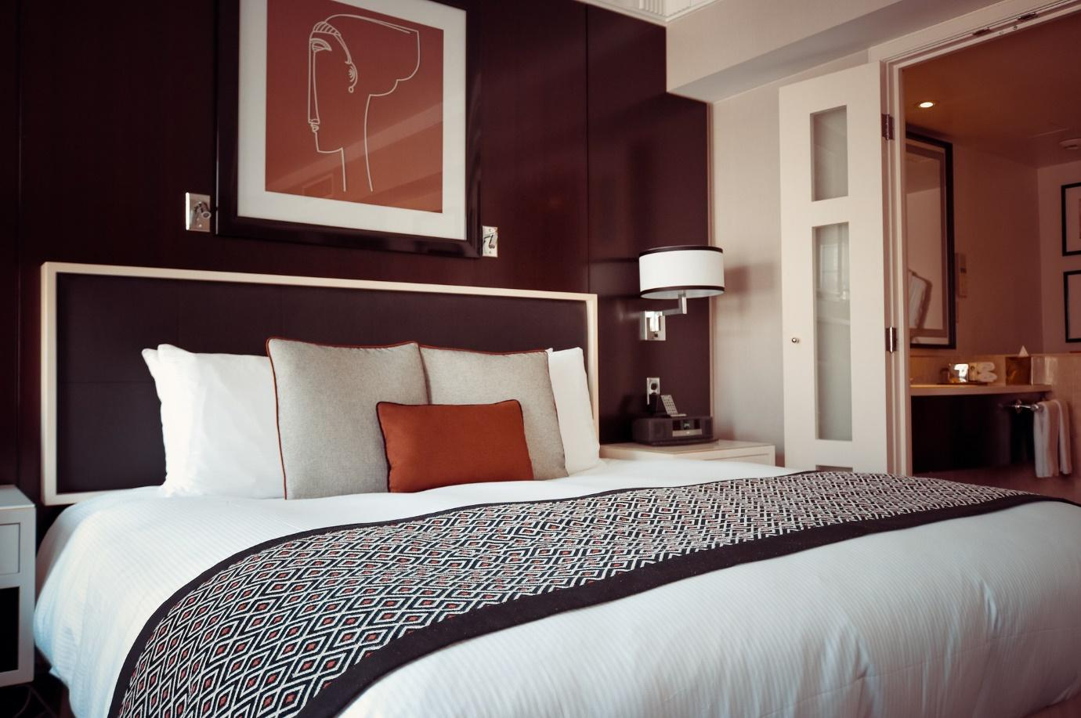

Perfect haven for business and pleasure. Enjoy more space with your own lounge area complete with comfortable chaise couch, desk, fridge & microwave. Ensuite features bath & separate shower, double handbasins & washer/dryer.

47m², Super King bed, 1-2 guests.

Air-conditioning, 55" flat screen TV with SKY channels, FREE unlimited WiFi.

**Two Bedroom   
$329 per night**

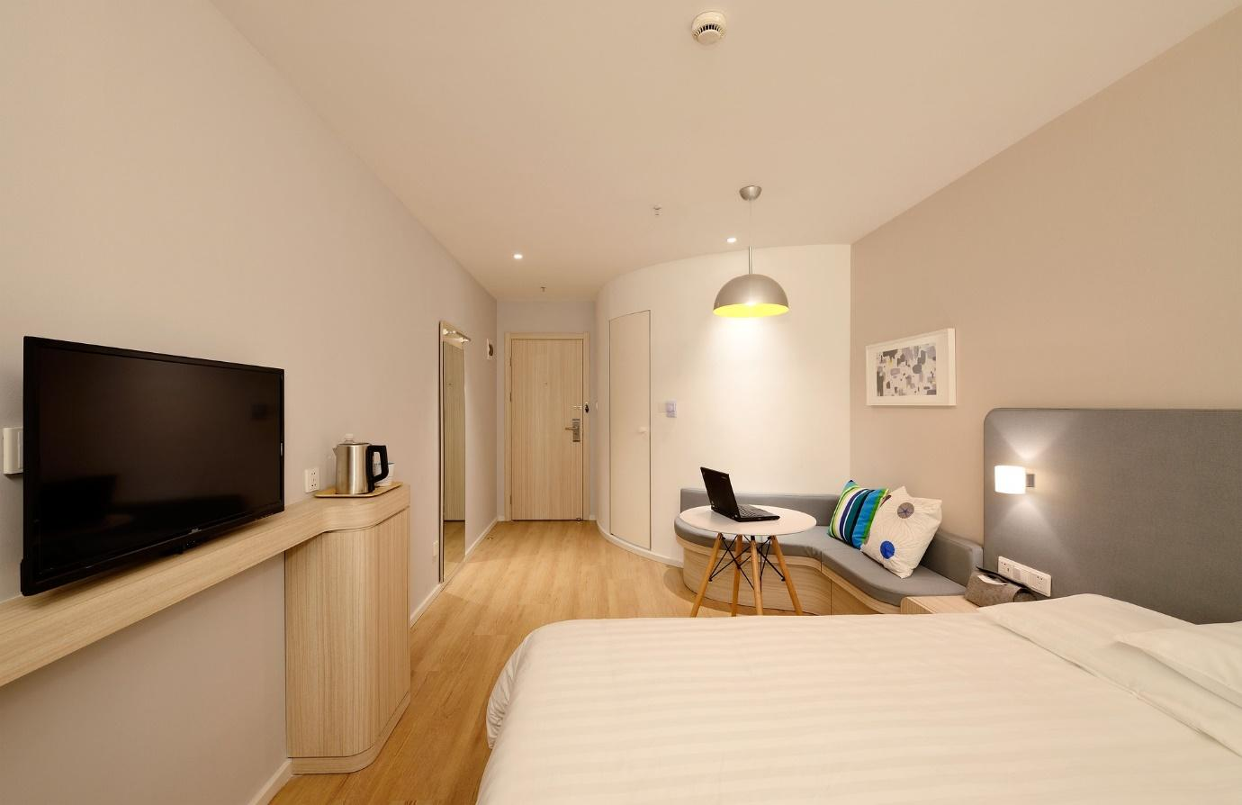

Stunning suites offering sophisticated style and space. Relax in the large living/dining area or host friends & colleagues. 2 separate bedrooms both with 55" TVs. Bathroom with walk in shower & double showerheads, washer & dryer.

65m², Super King + 2 Single beds, 1-4 guests.

Air-conditioning, 3 x 55" flat screen TV with SKY channels, FREE unlimited WiFi.

**Family Suite  
$289 per night**

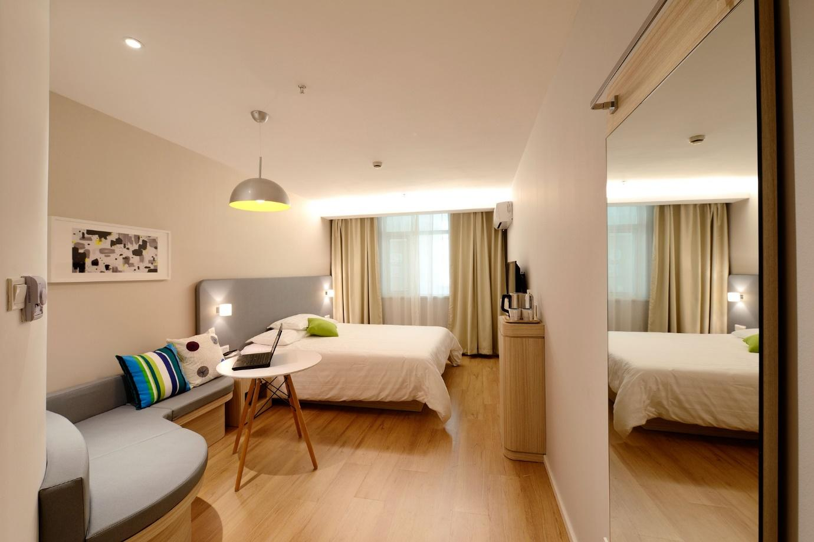

Excellent choice for a family or groups of friends wanting more space. Kids can enjoy their own bedroom. Ensuite with luxurious walk in shower & double showerheads, washer/dryer. Microwave & refrigerator.53m², King + 2 Single beds, 1-4 guests.

Air-conditioning, 2 x 55" flat screen TV with SKY channels, FREE unlimited WiFi.

**Step Two: Make a Reservation Now:**

Select your room from the following options:

 Superior Room Family Room Executive Suite Two Bedroom Suite



**Step Three - Induldge yourself**

Why not take the stress out of your visit and add some extra special services to your stay with us.

Buffet Breakfast - $25 per person  
Facial - $40  
Full body Massage - $60  
Portable Cot - FREE

